Chemical Bonding

What is a chemical bond?
bond = something that binds, attaches or restrains
chemical bond = the force that binds atoms to each other

Why do atoms bond?
to achieve stability (= noble gas configuration: …s²p⁶)

- “Octet Rule”
“Representative (Main-block) elements form bonds by rearranging electrons so that each atom has a stable octet in its outermost energy level.”
(Exception: Duet Rule – H will react to have a full 1s energy level with 2 electrons)

Valence electrons = electrons involved in bonding, those in the outermost energy level of an atom (main-block; others may involve d energy as well)

- Electron Dot Diagrams (Lewis Structure)

Using X to mean any element, draw Lewis Structures for elements in these groups:
Group 1 Group 2 Group 13 Group 14 Group 15 Group 16 Group 17 Group 18

X X X X X X X X

Note: The element’s symbol represents the element’s core electrons, while dots represent the valence electrons:
e.g. Na •

1s²2s²2p⁶ 3s¹

Application of Octet Rule to Ionic Compounds:
Metals lose electrons to become cations.
e.g. Na Na⁺ + 1e⁻

Nonmetals gain electrons to become anions.
e.g. Cl + 1 e⁻ Cl⁻

Whiteboard work:
formation of NaCl – electron dot diagram and orbital notation
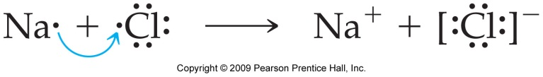
[ ]

then magnesium oxide, calcium fluoride, aluminum oxide, ammonium chloride

Types of Chemical Bonds
ionic, metallic, covalent, covalent network
Type of bonding properties of the chemical compound

Ionic compounds (salts)
Salts are made of charged particles formed by donating (and receiving) electrons.
Note: Salts are neutral compounds, (+) = (-)
- held together by electrostatic forces of attraction between (+) and (-) charges in a crystal lattice
- crystalline at room temperature (~ 24ºC): repeating 3-D structure in crystal lattice = unit cell (e.g. NaCl = cubic)
- strength of the ionic bond is amplified throughout the crystal structure
- hard
- brittle
- high m.p., high b.p. (due to compounded attraction of opposite charges in crystal lattice)
- soluble in water
- conduct electricity when molten or when dissolved in water (breaks down the crystal lattice, so charges can move)
- do not conduct electricity when solid
Energy considerations:
- Forming a crystal lattice loss of a lot of PE ↑ stability
- “lattice energy” = energy released when a crystal containing 1 mole of an ionic compound is formed from gaseous ions.
Bonding terms

Chemical formula:
shows relative numbers of atoms of each kind in a chemical compound by using atomic symbols and numerical subscripts. e.g. C₂H₄

Empirical formula:
smallest whole number ratio of atoms. e.g. CH₂
(subset of chemical formula)

Formula unit:
smallest whole number ratio for ionic compounds
(= empirical formula, except for Hg₂²⁺). e.g. NaCl

Molecular formula:
chemical formula of one molecule. e.g. C₂H₄

Structural formula: H H
hows how atoms are bonded together in a molecule. e.g. C=C
H H
Naming Monatomic Ions

nomenclature = “naming”
from Latin nomen = “name”, calare = “to call”

monatomic ion vs. polyatomic ion
1 atom + or - many atoms + or –

Use atomic symbol plus the charge (as superscript).
1. monatomic cation:
Na⁺ sodium ion element’s name + “ion”

2. monatomic anion:
Anions provide the second part of the name of an ionic compound.
Cl⁻ chloride ion use suffix “ide” + “ion”

S²⁻
N³⁻

How do you figure out the charge on an ion?

- Apply the Octet Rule (Groups 1, 2, 16, 17, many elements in Groups 13, 14, 15).

- Memorize ion list….

Naming cations with > 1 possible charge

Use Roman numerals:
e.g. copper(I) ion = Cu⁺
copper(II) ion = Cu²⁺

(Note: Arabic numbers are used to denote # of atoms in a compound; are used as subscripts.)

Naming Polyatomic Anions

Polyatomic anions are usually oxyanions, and contain oxygen atoms covalently bonded to a central nonmetal or metal ion. In order to fulfill the Octet Rule, these compounds gain one or more electrons, giving them an overall charge.

“ite” NO₂⁻ nitrite SO₃²⁻ sulfite
more oxygen “ate” NO₃⁻ nitrate SO₄²⁻ sulfate

ClO⁻ hypochlorite least oxygen
ClO₂⁻ chlorite
ClO₃⁻ chlorate
ClO₄⁻ perchlorate most oxygen

MnO₄⁻ permanganate

If the anion contains hydrogen, prefix name with “hydrogen”

HCO₃⁻ hydrogen carbonate
HSO₄⁻ hydrogen sulfate
HS⁻ hydrogen sulfide

Binary Ionic Compounds

cation + anion

Na⁺ Cl⁻

NaCl sodium chloride

1. Write ions Pb⁴⁺ O²⁻
- Balance charges by finding least common multiple of the ions’
charges. 4+ 2 x 2-
- Write formula using the lowest whole number ratio of the compound’s atoms.
= “empirical formula” (ionic and molecular compounds)
= “formula unit” (ionic compounds only)
PbO₂ lead (IV) oxide

Practice:
calcium chloride iron (II) oxide iron (III) sulfide

aluminum nitride strontium phosphide rubidium iodide

Ionic Compounds Containing Polyatomic Ions
many atoms + or –
Note: There are only a couple of polyatomic cations, but many polyatomic anions.

Use atomic symbols plus the charge (as superscript).
1. polyatomic cation:
NH₄⁺ ammonium ion
2. polyatomic anion:
OH⁻ hydroxide ion
CO₃²⁻ carbonate ion
Note: Charge refers to whole group of atoms, not just the last one.

How do you write polyatomic ion formulae?

1. Write ions NH₄⁺ CO₃²⁻
- Balance charges by finding least common multiple of the ions’
charges. 2 x 1+ 2-
- Write formula using the lowest whole number ratio of the compound’s ions. Show > 1 polyatomic ion with parentheses. (NH₄)₂CO₃ ammonium carbonate

Practice:
aluminum sulfate magnesium hydroxide copper (II) acetate
(See flowchart in textbook, p. 227)

Metallic Bonds (metals)
- held together by the attraction of free-floating valence electrons (-) for the (+)-charged metal ions in a lattice structure
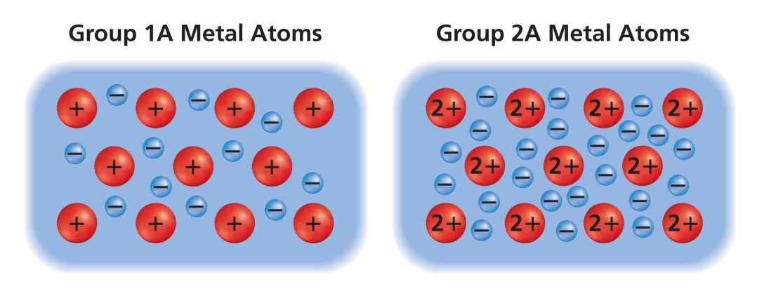
1. What is a regular, repeating three-dimensional arrangement of atoms called?
_________________________________________________________________________

2. Do the separate electrons that are shown belong exclusively to a single atom?
What word is used to describe such electrons? ___________________________________

3. Are the electrons shown the only ones actually present? Explain.
_________________________________________________________________________

4. Why are the central atoms shown as positively charged?
_________________________________________________________________________

5. How does the number of separate electrons shown for the group 1A metal atoms compare to the number
of atoms? Explain why in terms of valence electrons.
__________________________________________________________________________
__________________________________________________________________________

- How does the number of separate electrons shown for the group 2A metal atoms compare to the number of atoms? _________________________________

- What holds the metal atoms together in such an arrangement?
_________________________________________________________________________
_________________________________________________________________________

- What term is used to describe this model of metallic bonding? ______________________________

- How well do metals tend to conduct electricity? How does the model of metallic bonding account for that property? ____________________________________________________________________
________________________________________________________________________________

- Do metals tend to be brittle, or are they malleable and ductile? How does the model of metallic bonding account for that property? __________________________________________________________
________________________________________________________________________________
________________________________________________________________________________

Characteristics of metals
- high m.p. and b.p.
- good conductors of electricity and heat in the solid state
- malleable, ductile
- shiny, reflective

Alloys
- mixture of elements that has metallic properties (solid solutions)
  - substitutional alloys – atoms of similar sizes,
e.g. brass (Cu + Zn), bronze (Cu + Sn + Zn),
pewter (Sn + Sb + Pb)
  - interstitial – much smaller atoms fill spaces between larger atoms, e.g. carbon steel

Covalently-bonded compounds (molecules)

- held together by shared electrons (= covalent bond) e.g. H₂

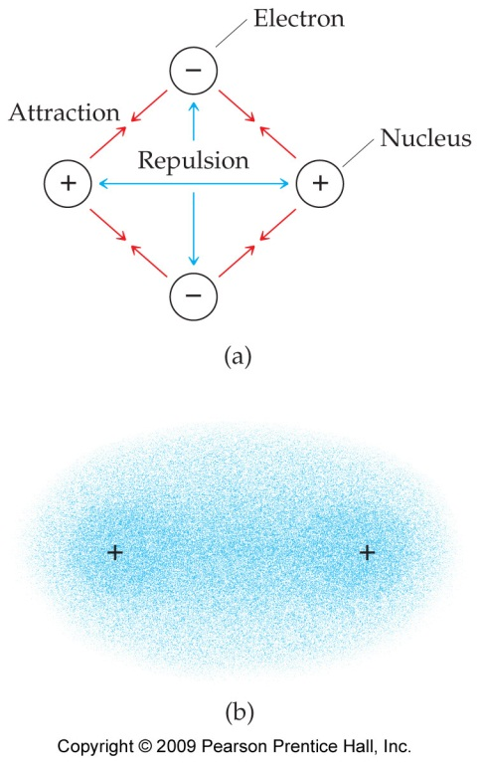
Both electrons spend some time around each nucleus, but majority of time in the middle.
∴ greater (-) charge in middle, so nuclei stay attracted.
*Memorize: N O F Cl Br I H
all exist diatomically in nature (more stable): N₂ O₂ F₂ Cl₂ Br₂ I₂ H₂
7- rule: Go to Element #7, travel across to Group 7A, then down in the shape of a 7.
Hairogens: H₂ (H), N₂ and O₂ (air), F₂, Cl₂, Br₂, I₂ (halogens)

Characteristics of covalently-bonded compounds (molecules)
- relatively low m.p., b.p.
- do not conduct electricity under any circumstances
- generally not soluble in water, but soluble in alcohol

Covalent Network Solids

form covalent bonds in all directions continuous network of strong covalent bonds no individual molecules

extremely hard, very high m.p. and b.p.

nonvolatile, insoluble in all solvents

brittle, nonconductors of heat and electricity

diamond (C), quartz (SiO₂)

Compare structures of networks/lattices:

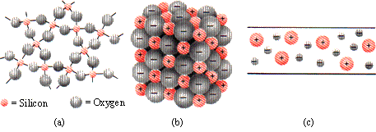

- covalent network (quartz, SiO₂)
- salt (NaCl)
- metal (e.g. Cu)

Formation of a Covalent Bond

• A covalent bond forms when the orbitals on two atoms overlap.
There are two electrons (usually one from each atom) of opposite spin in the orbital overlap.

• As two nuclei approach each other their atomic orbitals overlap.
• As the amount of overlap ↑, the energy of the interaction ↓.
• At some distance the minimum energy is reached = bonding distance (or bond length).
• As the two atoms get closer, their nuclei begin to repel and the energy ↑.
• At the bonding distance, the attractive forces between nuclei and electrons just balance the repulsive forces (nucleus-nucleus, electron-electron).
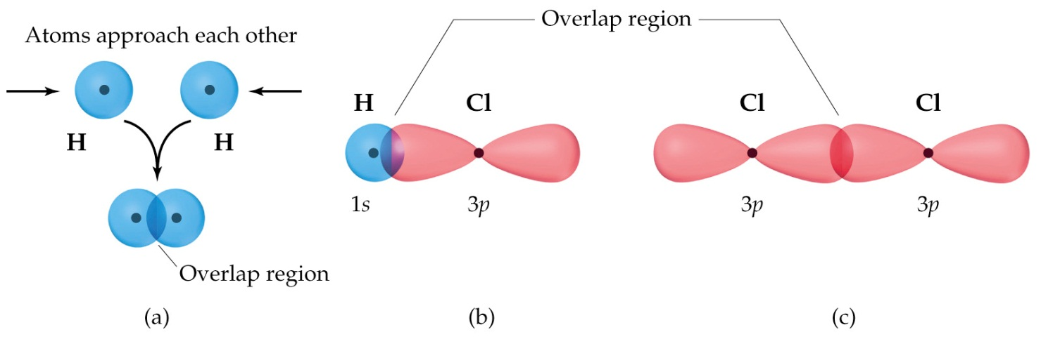

Energy considerations
What does “stable” mean? Changes that lower potential energy are favored.

In covalent bonds:
Shared electrons loss of PE ↑ stability
Bond energy = energy required to break a chemical bond and form neutral atoms

Relationship between bond length and bond energy in molecules
Bond length = average distance between two bonded atoms (distance of minimum potential energy)

As E_{bond} ↑, Length_{bond} ↓, because the closer the atoms are, the more attraction between nuclei and electron clouds. ∴ harder to separate.

Naming Molecular Compounds
See p. 248 in textbook for list of prefixes to memorize

A. Prefixes, roots, suffixes
- Begin with element with lowest electronegativity. nitrogen
- Add appropriate prefix (unless it is mono-). dinitrogen
- End second element with "ide" (as for ionic compounds…). oxide
- Use appropriate prefix for second element. tetroxide
- dinitrogen tetroxide
- N₂O₄

Practice:
CCl₄

CO

CO₂

As₂S₃

P₂O₅

P₄O₁₀

Compounds That Become Acids When Dissolved in Water

General Formula: HX H⁺ X⁻
monatomic
or
polyatomic
anion

Three Rules:

1. When X ends in “ide” (e.g. chloride, cyanide)
“hydro_______ ic acid”
e.g. hydrochloric acid, hydrocyanic acid

2. When X ends in “ite” (e.g. chlorite, sulfite)
“______ous acid”
e.g. chlorous acid
sulfurous acid

3. When X ends in “ate” (e.g. chlorate, sulfate)
“______ ic acid”
e.g. chloric acid
sulfuric acid

Your turn: HBr

HNO₂

HNO₃

Writing Lewis Structures (Electron Dot Diagrams) for
Molecules and Polyatomic Ions

- Count up the total # valence electrons for all atoms in molecule or ion.
Molecule: sum the # electrons in all atoms
Ion: sum the # of valence electrons + charge on ion

- Write down the symbols of atoms to show how joined.
- If carbon, usually in center
OR
- most electropositive atom in center
OR
- nonmetal in center (not H, O)

- Trial drawing with dots (2 for H, 8 for others)
If pair left over, make = or ≡
- Maybe an exception: more or less than 8 in valence
Practice:
CH₃Br ClO⁻ C₂H₆

BrI SO₄²⁻ C₂H₄

H₂S H₂PO₄⁻ C₂H₂

PH₃ NH₄⁺ C₆H₆
Molecular Geometry

Basic Molecular Shapes

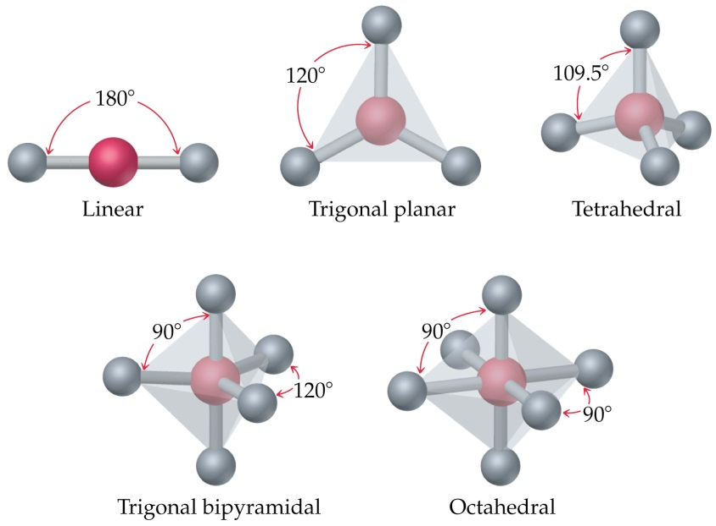

We count only the atoms when describing the shape of a molecule:

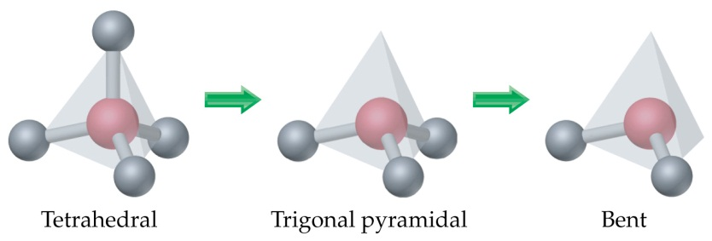

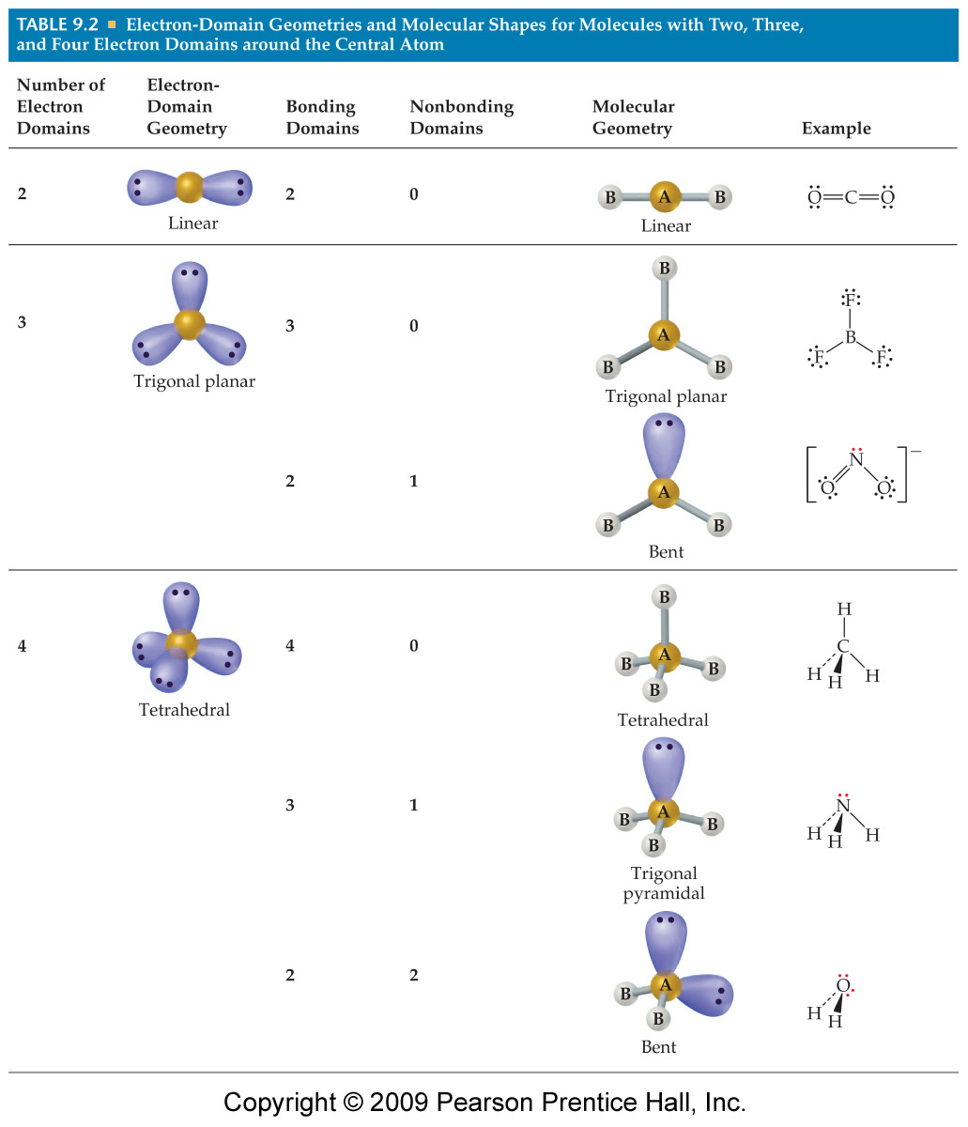
(AP Chem)
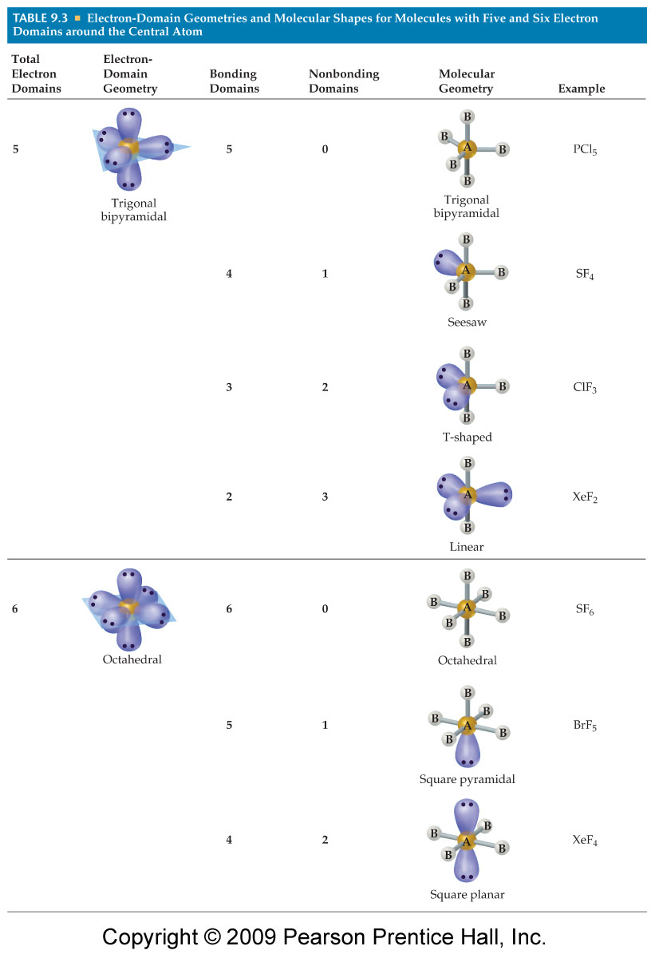
(Honors &
AP Chem)
(Honors &
AP Chem)
(AP Chem)
(AP Chem)
(AP Chem)

What determines the type of chemical bond?

Differences in electronegativities between bonding atoms
The greater the difference more ionic (on a continuum, where a difference of 1.7 is approximately 50:50 ionic:covalent)
polar nonpolar covalent
4.0 ionic 2.0-1.7 covalent 0.4 0.0

e.g. electronegativity of Cl - electronegativity of Na
3.0 - 0.9 = 2.1 ionic
electronegativity of Cl - electronegativity of Al
3.0 - 1.5 = 1.5 polar covalent
electronegativity of Cl - electronegativity of Br
3.0 - 2.8 = 0.2 nonpolar covalent

ionic bonds - the least electronegative atom donates 1 or more electrons to the more electronegative atom

covalent bonds - electrons from both atoms are shared
nonpolar - electrons are shared equally by both atoms
polar - electrons are not shared equally - the more electronegative atom attracts the shared
electrons more strongly

Predicting Polarity in Molecules

Draw electron dot diagram (Lewis structure) of the molecule.

Compare the electronegativities of each of the bonded atom pairs.

Note whether each bond is polar (P) or nonpolar (NP).

Draw an arrow towards the most electronegative atom for each bond.

Is molecule symmetrical? (if so, molecule is NP)

Examples:

CH₄ CCl₄ CH₃Cl

NH₃ CO₂ H₂O

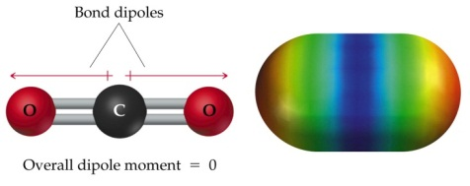

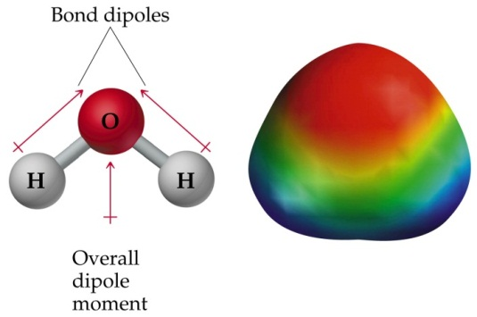

Effect of bond polarity on molecule polarity

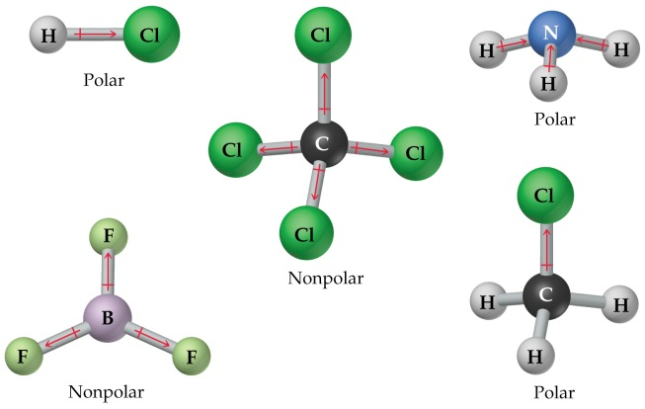

Intermolecular forces (van der Waals forces)

- Dispersion or “London” forces (nonpolar molecules)
(named after Fritz London, 1900-1954)
- weakest intermolecular force
- results from the constant motion of electrons uneven distribution of electrons at any particular moment:
“temporary dipole” which may dipole in nearby molecule.
- acts on all molecules all the time
- only intermolecular force acting among noble gas atoms and nonpolar molecules
- ↑ with ↑ number of electrons: note m.p., b.p.
e.g. halogens
F₂, Cl₂ gases at room T
Br₂ liquid at room T (larger than F₂ and Cl₂)
I₂ solid at room T (largest)

- Dipole force (polar molecules)
a. the attraction between two polar molecules:
(-) end of one polar molecule attracts the (+) end
of another polar molecule
- more polar stronger dipole force
- closer together stronger dipole force

3. Hydrogen bonding
- always involves H
usually involves O, F or N (small, high electronegativity)

- strongest intermolecular force

How strong? 5% of the strength of a covalent bond

- higher b.p. and higher viscosity

- e.g. H₂O

Comparing Bond Types
Properties | Ionic: salts | Metallic: metals | Covalent: molecules | Covalent network
Description of bond
General appearance
Malleable vs brittle
Conduct electricity?
under what circumstances?
Soluble in water or organic solvents?
m.p., b.p.

State of matter at room temp?

Comparing ALL bond types:

Which is stronger?

covalent network > metallic > ionic > covalent (molecules) > H bond > dipole > dispersion

e.g. Compare melting points:

SiO₂ > Fe > NaCl > C₁₂H₂₂O₁₁ > H₂O > HCl > H₂
sand > iron > salt > sugar > ice > hydrogen chloride > hydrogen gas

